The Conventional Wisdom on China’s Island Bases Is Dangerously Wrong
Gregory B. Poling January 10, 2020
https://warontherocks.com/2020/01/the-conventional-wisdom-on-chinas-island-bases-is-dangerously-wrong/
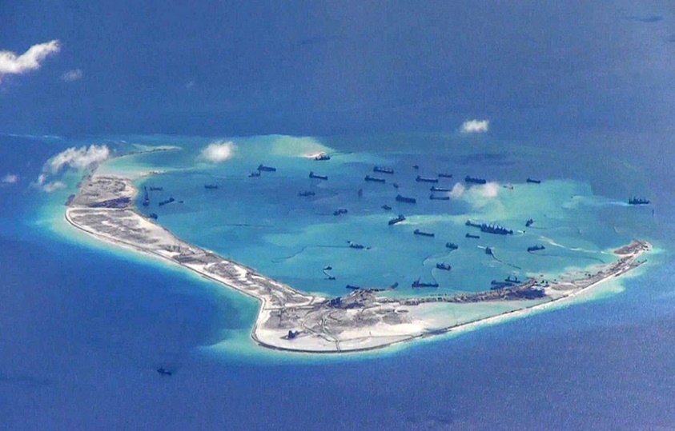
Image: Wiki Commons
Last month, during a conference on China’s maritime ambitions, I was asked a question I often get about Beijing’s artificial island bases in the South China Sea. That question goes something like this: Couldn’t the United States easily neutralize these remote outposts in a conflict, negating their value? The assumption is understandable given how seemingly remote the facilities are and how accustomed Americans have become to uncontested dominance over the sea and air. But it is flawed. In fact, China, not the United States, would control the sea and airspace of the South China Sea at the outbreak of hostilities thanks to its artificial island bases. And given current American force posture in the region, it would be prohibitively costly for the United States to neutralize those outposts during the early stages of a conflict. That would make the South China Sea a no-man’s land for most U.S. forces (submarines excepted) during the critical early stages of any conflict — giving the islands considerable military value for Beijing.
This answer provoked enough of a stir among conference attendees that I took to Twitter to see what fellow South China Sea watchers and security experts thought. Their responses were overwhelmingly consistent with my argument and added several concerns for the United States that I had overlooked. This confirmed a worrying disconnect. Most of those who follow the South China Sea most closely see China’s artificial island bases as major gamechangers in any future Sino–U.S. conflict. Yet the conventional wisdom throughout Washington still seems to be that they can be safely dismissed as lacking strategic value. That’s wrong.
The main purpose of China’s artificial islands is not to help fight a war against the United States. Beijing’s primary strategy in the South China Sea is to use civilian and paramilitary pressure to coerce its Southeast Asian neighbors into abandoning their rights. Thanks to the facilities on its island bases, hundreds of militia vessels and a large number of coast guard ships are based hundreds of miles from the Chinese coast for months at a time. They engage in frequent harassment of civilian and law enforcement activities by neighboring states, making it prohibitively risky for Southeast Asian players to operate in the South China Sea. The threat of Chinese naval and airpower, meanwhile, dissuades neighboring states from using more forceful military responses against these illegal actions. Left unchallenged, this primarily nonmilitary strategy will secure Chinese control over the waters and airspace of the South China Sea in peacetime and undermine America’s role as a regional security provider. It will make clear to Southeast Asian partners that a security relationship with the United States cannot safeguard their interests in the face of a rising China and will thereby undercut the rationale for governments like the Philippines and Singapore to support the U.S. military presence in the region.
But China also recognizes that its strategy might fail. It could miscalculate, provoking a violent conflict with the United States. Or a fight could start in Northeast Asia and spread south. The People’s Liberation Army has therefore invested in facilities and deployments in the Spratly Islands that not only support its current peacetime coercion but also favorably shift the balance of power in any future conflict. As a result, the islands not only guarantee China air and surface dominance in the South China Sea in the opening stages of a conflict, but they are also far more difficult to neutralize than conventional wisdom suggests. The Asia Maritime Transparency Initiative at CSIS has exhaustively documented the growth of these capabilities using commercial satellite imagery and other remote sensing tools.
China has constructed 72 fighter jet hangars at its three airbases in the Spratlys — Fiery Cross, Mischief, and Subi Reefs — along with another 16 on Woody Island in the Paracels. It has so far held off on deploying combat aircraft to the Spratlys but rotates J-11 fighters frequently through Woody. Assuming it was the first mover in a conflict, it would be able to deploy combat aircraft rapidly to the airfields in the Spratlys, instantly establishing air dominance in the theater. Unless the Chinese happened to pick a fight when U.S. forces were engaged in a major exercise like Balikatan in the Philippines, the closest U.S. ground-based combat aircraft would be in Okinawa and Guam, approximately 1,300 and 1,500 nautical miles away, respectively. The only U.S. military planes in the region would be patrol aircraft in the Philippines and potentially Malaysia.
China has, meanwhile, deployed YJ-12B and YJ-62 anti-ship cruise missiles to its outposts in the Spratlys and Paracels, backed by longer-range missile capabilities from the mainland. And it has invested heavily in radar and signals intelligence capabilities on all the islands, making it a safe bet that it sees just about anything moving on or above the South China Sea. A U.S. Navy vessel sailing in those waters would be well within the range of Chinese fire when hostilities broke out. Lacking supporting ground-based fire or air cover, the only rational option would be to pull back to the Sulu and Celebes Seas, and probably beyond, as quickly as possible. This would be especially true of any U.S. aircraft carrier that happened to be in the theater, since it would be far too valuable to leave in such an indefensible position.
In the face of these Chinese advantages, could the United States still neutralize the island bases early in a fight? Probably, but not at an acceptable cost. Doing so would require expending a lot of ordnance likely desperately needed in Northeast Asia, diverting important air and naval platforms and placing them at risk out of proportion to the potential battlefield gains.
The island facilities are considerably larger than many observers seem to realize. As Thomas Shugart, then a visiting fellow at the Center for a New American Security, once pointed out, most of the District of Columbia inside the I-495 beltway could fit inside the lagoon at Mischief Reef. Pearl Harbor Naval Base could fit inside Subi Reef. The critical infrastructure that would need to be hit to seriously degrade Chinese capabilities is spread out across a considerable area. That amounts to a lot of ordnance to drop, even if the goal were just to hit critical nodes like sensors, hangars, ammunition depots, and command and control facilities.
Disabling the airstrips themselves would be an even taller order. The United States fired 59 Tomahawks at the Shayrat Air Base in Syria in 2017, all but one of which hit, yet the runway was back in operation just a few hours later. Considering that China has deployed HQ-9 surface-to-air missiles and constructed point defenses at all these bases, some percentage of missiles fired would never reach their target. And much of the infrastructure has been hardened, including China’s missile shelters, larger hangars, and buried ammunition depots. The most effective means of cratering the runways themselves would be to drop heavier ordnance from the air, but that would put high-value U.S. bombers at unacceptable risk in a secondary theater (more on that below). So a safer bet would be to just focus on hitting key information nodes with longer-range munitions. A hundred cruise missiles per outpost would not be an unreasonable estimate to effectively disable the bases. That amounts to 300 missiles just for the major bases in the Spratlys, another 100 for Woody Island, and dozens more if the United States wanted to disable smaller facilities (for instance, the heliport on Duncan Island that would likely be used for anti-submarine warfare operations).
What platforms would launch these hundreds of cruise missiles? The only thing safely operating in the theater after hostilities started would be U.S. submarines. They would find it a lot harder to remain undetected in the face of active Chinese anti-submarine operations once they started shooting. Every launch would put them at some risk. And in that environment, U.S. subs would likely be busy attacking Chinese surface ships and other high-value platforms, not trying to blanket thousands of acres of infrastructure at Mischief or Subi Reefs with valuable ordnance with no guarantee of success. Anything else sent into the theater — long-range bombers from Guam, surface ships, etc. — would be operating at high risk given Chinese dominance of the sea and air space.
No matter how the ordnance was delivered, the math would be the same. Effectively neutralizing China’s bases would require hundreds of missiles, emptying the magazines of valuable U.S. platforms that don’t have ordnance to spare. And it would do so in what is sure to be a secondary theater. It is hard to imagine a scenario in which the United States would be seriously considering kinetic strikes on Chinese bases in the South China Sea that would not also involve fighting in Northeast Asia. That would mean that anything the United States launched against the Spratlys would be something it could not use for operations in defense of U.S. and Japanese forces or for the relief of Taipei.
This punishing math could be changed, especially by the full implementation of the Enhanced Defense Cooperation Agreement to allow rotational deployments of key U.S. capabilities in the Philippines. These should include combat aircraft at Basa Air Base on Luzon and Antonio Bautista Air Base in Puerto Princesa to contest Chinese air dominance over the South China Sea. And it should include preparations to rapidly stand up U.S. fire bases at these and other facilities in case of hostilities to hold Chinese outposts and ships in the South China Sea at risk.
Barring an unexpected change of heart, these plans are unlikely while Rodrigo Duterte remains president of the Philippines through 2022. In the meantime, the United States can lay the groundwork for full implementation of the defense cooperation agreement by undertaking more ambitious infrastructure projects at agreed-upon sites and pushing the Armed Forces of the Philippines to support those upgrades. It should also push for more opportunities to deploy combat aircraft to defense cooperation sites as part of bilateral exercises, as American F-16s were for the first time at Basa last year. This would help acclimate both sides to U.S. fighters operating from these bases and, if frequent enough, could strengthen deterrence by giving the United States some rapid-response capability in the South China Sea. But these steps will not fundamentally alter the math.
Without the Enhanced Defense Cooperation Agreement, or some undiscovered (and unlikely) stand-in, U.S. forces would have little choice but to concede the waters and airspace of the South China Sea to China in the opening stages of a conflict. The logistics and maintenance hurdles China would face during wartime would likely prevent its island bases from effectively operating over the long-term. But for several weeks at least — time that would be critical in a Taiwan contingency, for instance — they would pay huge dividends for Beijing. So long as the United States lacks ground-based combat aircraft and fire bases along the South China Sea, American planning needs to acknowledge that reality.
Gregory B. Poling is director of the Asia Maritime Transparency Initiative and a fellow with the Southeast Asia Program at the Center for Strategic and International Studies in Washington, D.C.

