Bringing Back the Punitive Expedition
Kevin Benson | December 16, 2019
https://mwi.usma.edu/bringing-back-punitive-expedition/
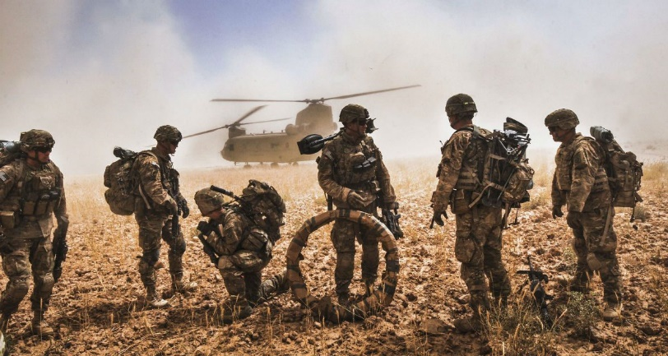
Image credit: Staff Sgt. Whitney Houston, US Army
Because ends exist only in the imagination, they can be infinite. . . . Means, though, are stubbornly finite…Ends and means have to connect if anything is to happen. They’re never, however, interchangeable.
— John Lewis Gaddis, On Grand Strategy
In October 2019 we marked the eighteenth anniversary of the start of operations in Afghanistan—and with each year, the “Forever War” label applied by some pundits becomes more difficult to argue with. After eighteen years of conflict, lost lives and expended treasure it is past time to consider other options for action in the Department of Defense range of ways to more effectively employ military power. The range of military responses offered to a president who must do something in response to an incident sufficiently jarring to the national psyche must include punitive expeditions.
Given the scope of poorly governed and ungoverned spaces on the planet and the “stubbornly finite” means that Gaddis describes, a carefully crafted punitive-expedition option establishes a measured response to the action of a foe, is within the scope of existing laws of land warfare, and offers focus for military action taken in support of a policy objective. It is time to reconsider the military’s use of them. Including a punitive-expedition option when developing use-of-force options for policy makers fits into the absolute requirement to connect policy ends to the finite means of both military forces and sustaining the support of the people for a desired policy objective.
Application of Punitive Measures
Bearing in mind the Clausewitzian trinity—enmity, chance, and reason—and the effort required to sustain the will of the nation, the military must resurrect the option of the punitive expedition. After an attack like the one on 9/11 the demand for action will be irresistible. The Clausewitzian definition of war reminds us of the purpose of deciding to use force. “War is thus an act of force to compel our enemy to do our will.”
Another reason to bear Clausewitz in mind is his rejoinder regarding bloodshed and the use of force:
Kind-hearted people might of course think there was some ingenious way to disarm or defeat an enemy without too much bloodshed, and might imagine this is the true goal of the art of war. Pleasant as it sounds, it is a fallacy that must be exposed: war is such a dangerous business that the mistakes which come from kindness are the very worst. The maximum use of force is in no way incompatible with the simultaneous use of the intellect.
A punitive expedition results in a measured, relatively swift, focused response. It can be of some duration but only long enough to achieve the policy ends of punishing the group that threatened US interests or caused US casualties. There is no regime change, no re-ordering of the existing power structure in a region. A punitive expedition demonstrates the will and ability of the US government to act with violence. Especially when striking into ungoverned areas there is no Phase V (enable civil authority) as there is no civil authority to reestablish. The purpose of the punitive expedition is to act with violence and return to home station. The linkage to policy is straightforward. In ungoverned or poorly governed spaces, a punitive expedition is measured, focused, and not open-ended. A punitive expedition acts with diplomatic and informational efforts, each reinforcing the other. Indeed strategists and planners must bear in mind the political object irrespective of the development of use of force options. Again we return to Clausewitz: “The political object—the original motive for the war—will thus determine both the military objective to be reached and the amount of effort it requires.”
A punitive expedition is not the “easy button”; rather, it is a more difficult operation to conceive because it requires a recognition of the limits of force. The need to bear in mind the policy end at which the use of force is aimed remains paramount prior to and during the operation. Moreover, the ability to cease, escalate, or deviate operations will need to be as dynamic as the political climate demanding action. The dialogue between the senior civilian policymakers and the military requires constant engagement—and, I offer, more effort on the part of the military. Planners and military decision makers must develop a range of response options conforming to an understanding of the need to do something now with an equal understanding of the conditions driving policy. And policy will change as conditions change, polls measure the limits of public support, and social media observations turn into developing and competing narratives. These conditions act as limits on the utility of using force.
Beginning with the End in Mind
The multi-phased approach to planning conflicts remains useful in order to structure and synchronize the dynamic and daunting tasks of accomplishing military objectives that achieve political conditions favorable to the United States. Again, the successful execution of any strategy demands a recognition of the ever-balancing Clausewitzian trinity: enmity, chance, and reason. The government, purveyor of reason, must remain engaged in the conduct of the war while sustaining the passion of the people to support the war.
Short of declaring war, which is apparently antiquated in this modern age, and even asking the legislative branch to remain engaged by reviewing and updating the authorization for the use of military force, it falls on the military to bear in mind framing the war upon which the nation enters. As Clausewitz wrote,
The first, the supreme, the most far-reaching act of judgement that the statesman and commander have to make is to establish . . . the kind of war on which they are embarking; neither mistaking it for, nor trying to turn it into, something alien to its nature. (Emphasis added.)
The statesman and the commander must understand and agree to the kind of war upon which they are embarking—or in other words, the use of force as an extension of policy they are going to conduct. This is why it is so important that military people know how to speak to politicians and policymakers in a language they understand—not merely talking in terms of “body bags and trips to Dover,” but a clear understanding of and the ability to convey what the use of force can and, significantly, cannot do. As a quote attributed to Talleyrand goes, “you can do anything you like with bayonets, except sit on them.”
This is not to say the military is bloodthirsty and desires combat, but to acknowledge that the determination to use force as an extension of policy carries with it the fact people will die and property will be destroyed. The decision to use force must be made with a mind open to loss and the repercussions of loss in the Information Age of social media and twenty-four-hour news and political-commentary cycles.
Violence is Not an End within Itself
Punitive expeditions are merely the physical stimulant for changing behavior and only enable a greater effort to achieve decisive results within the psychological aspects of diplomatic and economic competition.
There are recent incidents wherein the threat of force gained policy objects without a shot being fired: Libya giving up its nuclear weapons in 2004, for example, and the Russian conquest of Crimea. Perspectives on these incidents abound but here again On War provides the ultimate observation:
Combat is the only effective force in war; its aim is to destroy the enemy’s forces as a means to a further end. That holds good even if no actual fighting occurs, because the outcome rests on the assumption that if it came to fighting, the enemy would be destroyed. (Emphasis added.)
As John Lewis Gaddis points out, connecting the means to the ends is difficult but vital. This ability must be in the military strategist’s intellectual toolkit. Including a punitive expedition into the proposed range of military responses to an enemy action can satisfy the need to act relatively swiftly and can assist in crafting a policy end within the ability of the applied means to achieve. A punitive expedition does not close the door on other options. A punitive expedition as a response option is also not a substitute for a strategy. But it can fit well into the conditions around which policy and strategy are developed and refined as conditions change—and strategists know conditions will change.
The narrative accompanying action must also be considered as a part of both the government policy and the supporting strategy. Playing well in Peoria is important, but a consideration of how the narrative plays in Paktia province and Paris must also be incorporated into both thinking and action. As Lt. Gen. Eric Wesley suggested during the 2019 Association of the US Army convention, whoever wins the narrative of the first battle may well win the war.
The purpose of the punitive expedition is to act with violence and return to home station. The linkage to policy is straightforward as execution of these types of expeditions will serve to demonstrate that the United States will reach out and take action to destroy a foe who threatens vital national interests and American lives. In ungoverned spaces, a punitive expedition is measured, focused, and not open-ended. A punitive expedition must act in coordination with diplomatic and informational efforts, each reinforcing the other. Indeed strategists and planners must bear in mind the political object irrespective of the development of use-of-force options.
It is time to return to consideration of punitive expeditions.
Col. (ret) Kevin Benson, PhD, commanded from company to battalion level and served as a general staff officer from corps to field army. He was the CFLCC J5 (Plans) at the start of Operation Iraqi Freedom and the director of the School of Advanced Military Studies. The views expressed are those of the author(s) and do not reflect the official position of the United States Military Academy, Department of the Army, or Department of Defense.
Author’s note: I wish to thank Lt. Col. Mark Lavin for his review and comments. All quotations from On War, Carl von Clausewitz. Edited and translated by Michael Howard and Peter Paret. Princeton, NJ: Princeton University Press, 1976.
------------------------------------------------------------
Half Measures Just Don’t Work: The Case Against Bringing Back the Punitive Expedition
Christopher Parker | January 16, 2020
https://mwi.usma.edu/half-measures-just-dont-work-case-bringing-back-punitive-expedition/
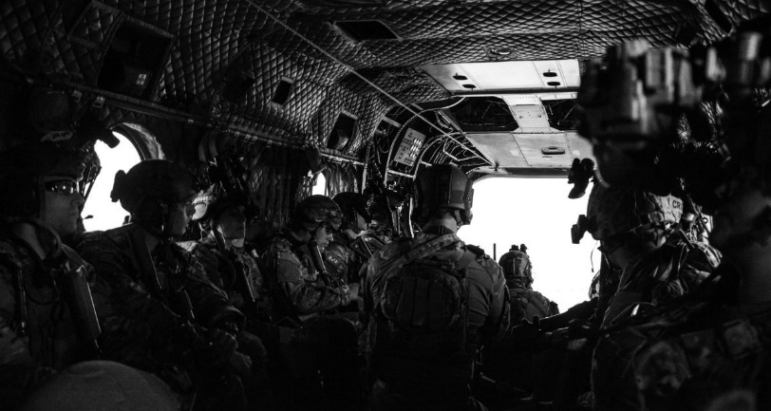
Image credit: Staff Sgt. Amber Martin, US Army
Let me conclude by saying that, based on this judgement and the one pronounced against the Latins, when one has to judge powerful cities and cities that are accustomed to living in liberty, it is necessary either to destroy them or to give them benefits; otherwise every judgment is made in vain. Above all one must avoid a middle course of action.
— Niccolò Machiavelli, Discourses on Livy
When Clausewitz included “primordial violence” in his “paradoxical trinity,” he was motivated to do so by the passions he witnessed during the French Revolution and the Napoleonic Wars—passions that inspired the French people to arms and led them on a doomed adventure to Moscow. However, this is not how passion is always operationally exploited. Beyond the cases that inspired Clausewitz, there are other actions that, instead of channeling passion toward grand objectives, do so by meting out violence in carefully measured doses. A prime example is the punitive expedition, a discussion of which was recently triggered by an article by retired Col. Kevin Benson. The punitive expedition is an interesting paradox. It is fueled by “primordial violence, hatred, and enmity,” but limited in its objectives. It seeks to inflict pain on an enemy, but not to completely destroy or eradicate the foe, only to change behavior or deter further disagreeable acts. Proponents of the punitive expedition suggest that it can be easily controlled; its duration is determined by the aggressor and its limited objectives ensure a swift campaign initiated and concluded on command. In this regard, the punitive expedition appears a viable option for policymakers forced to act, or react, to a national-security threat. However, this perspective neglects several characteristics of the punitive expedition that severely limit its applicability and raise doubt about its effectiveness as a tool for achieving long-term policy objectives. Inherently a measure too limited to achieve lasting effect, the punitive expedition is not likely to change the security landscape in a permanent or meaningful manner, its inability to deliver tangible political objectives makes it both costly and difficult to recruit partners, and limits to its applicability leave it unsuitable for addressing the majority of security challenges faced by the United States.
The punitive expedition is often cast as a scalable and relatively cheap means of retaliating against a foe while simultaneously deterring future misbehavior. As Dr. Benson noted in his article, “A punitive expedition results in a measured, relatively swift, focused response. . . . There is no regime change, no re-ordering of the existing power structure in a region. A punitive expedition demonstrates the will and ability of the US government to act with violence. . . . The purpose of the punitive expedition is to act with violence and return to home station.” Despite the allure of punitive expeditions as a policy option, it does not feature prominently in American military history. Its most notable use occurred in 1916 when President Woodrow Wilson dispatched Gen. John J. Pershing and ten thousand soldiers to Mexico to destroy Pancho Villa’s rebel army as a reprisal for killing fifteen Americans in Columbus, New Mexico. Failing to achieve their objective, Pershing’s forces returned home nearly a year later on the eve of a much larger war with Germany. More recently, although President Donald Trump’s retaliatory strikes against Syria were undoubtedly meant to punish the Assad regime for its use of chemical weapons and change its behavior, airstrikes do not meet the criteria of an expedition. This scant record is a function of the shortcomings inherent in punitive expeditions.
The greatest problem with the punitive expedition is the inescapable fact that, by its very nature, it is a half measure. Seeking not to reorder the power structure or bring about lasting change, the punitive expedition is a demonstration of violence meant only to change behavior. Victory is measured by the absence of further disagreeable acts by the enemy; there is no unconditional surrender, no seizure of territory, and no ultimate defeat—just the hope that the violence doled out was enough to deter for “long enough.” Political theorists and military strategists have long cautioned against half measures. In his Discourses on Livy, Machiavelli points to the Florentine Republic’s treatment of the rebellious city of Arezzo as an example of such ill-fated actions. Instead of acting decisively, the Florentines “employed that middle course of action which is extremely damaging in passing judgement on men; they banished some of the citizens of Arezzo, and they condemned others to death; they took away their honours and ancient ranks from everyone in the city; and they left the city intact.” Because they failed to act as the Romans, who “always avoided a middle course of action,” the Florentines were forced to return to Arezzo to quell future rebellions.
Contemporary statesmen have also cautioned against half measures. Struggling to codify strategic lessons in the aftermath of the Vietnam War, Secretary of Defense Caspar Weinberger outlined six tests for determining when and how the United States should use force abroad. Known thereafter as the Weinberger Doctrine, the second test proclaimed, “If we decide it is necessary to put combat troops into a given situation, we should do so wholeheartedly, and with the clear intention of winning. If we are unwilling to commit the forces or resources necessary to achieve our objectives, we should not commit them at all.” Clausewitz echoes this sentiment when he writes that “the best strategy is always to be very strong. . . . The first rule, therefore, should be: put the largest possible army into the field.” Swift, measured, and focused, the punitive expedition is hardly a full measure and, as these strategists have pointed out, half measures yield, at best, a temporary respite from combat (the Florentines) and, at worst, an ever escalating quagmire (Vietnam). Such actions in ungoverned or loosely governed spaces are sure to further destabilize these areas, necessitating additional military intervention later down the road. Aside from the challenges associated with its transitory outcomes, it can hardly be conceived that such an excursion would draw on the full extent of American military might, for, if it did, the return on investment would be woefully disappointing.
Another problem with the punitive expedition lies in its irrational calculus and hidden cost. While on the surface the punitive expedition may appear far cheaper than America’s forever wars in Iraq and Afghanistan, this neglects the fact that it does not deliver a tangible return on investment. As noted above, there is no “re-ordering of the existing power structure” and no seizure of territory. There is also, likely, no lasting peace. The punitive expedition accumulates neither power nor resources for the United States; however, it still costs both blood and treasure. It is the strategic equivalent of a carnival ride; it may be fun while it lasts, but it costs to ride and, in the end, you go home empty-handed. From the start this defies Clausewitz’s rational calculus for war, which states, “Since war is not an act of senseless passion but is controlled by its political object, the value of the object must determine the sacrifices to be made for it in magnitude and also in duration. Once the expenditure of the effort exceeds the value of the political object, the object must be renounced and peace must follow.” Yielding no tangible political objectives aside from a demonstration of violence, the punitive expedition is hard to justify in terms of the sacrifices it will undoubtedly require.
The costs of a punitive expedition are likely to be compounded by the lack of partners willing to sign on to the campaign and share the burden. With its lack of a tangible return on investment, recruiting partners who do not necessarily share in the original passion that spawned the expedition will be a hard sell. Without “re-ordering the existing power structure,” weaker third parties may be wary that their involvement will draw reprisals from a belligerent that remains in power. Not only will this drive up the cost of the campaign, but it will complicate things like access, basing, and overflight—all critical requirements for the United States to project power abroad.
While it may be difficult to recruit partners to a punitive expedition, identifying a suitable foe for which the campaign is an effective measure will likely prove even more elusive. Punitive expeditions are not feasible against peer threats capable of effectively resisting or escalating the conflict, for, in these situations, the punitive expedition is no longer measured nor swift. Nor are they likely to work against an existential threat, as the punitive expedition cannot deliver satisfactory political objectives when the adversary can hold the nation’s survival at risk. This leaves weaker, rogue states on the potential receiving end of a punitive expedition; however, there are significant issues here as well. Given that rogue states are often dominated by authoritarian parties or individuals, a sharp divide exists between the regime and the populace, and this divide heavily influences how we conceptualize the enemy. In these instances, the populace is largely viewed as the victim and the enemy is narrowly identified as the regime’s leadership and its security apparatus. Under such conditions, punishing the regime without compounding the suffering of the already victimized populace can prove exceptionally difficult, and, when large segments of society and its requisite infrastructure are ethically off limits, there is little room left to punish. Strategists must also carefully assess whether a punitive expedition will galvanize an already divided society, strengthening the regime’s popularity by bringing the people and the party together under shared hardship and a common enemy. The punitive expedition could only be effective in that rare circumstance when the rogue regime is supported by a large segment of its populace, thereby offering ample opportunity for the application of violence—a rare condition given the sociopolitical divide inherent in authoritarian states.
This paradox is best demonstrated through a comparison of the Allied conception of Nazi Germany during World War II and the United States’ approach to Ba’athist Iraq in 2003. Although neither of these campaigns were punitive expeditions, examining how the enemy was framed during each reveals the critical distinctions necessary in determining the suitability and acceptability of a theoretical punitive expedition. Air Marshal Sir Arthur Harris made no distinction between German and Nazi when he constructed a strategic bombing campaign that directly targeted the civilian populace. Known as “de-housing,” it offered an almost unending stream of targets and, had it been a punitive expedition, the options for inflicting punishment would have been enormous. While this is certainly an extreme end of the spectrum, it demonstrates that, in circumstances where the conceptual distance between the regime, the military, and the people is least, the greatest opportunity for punishment exists. By contrast, narrowly defining the enemy as a regime, its military, or even specific units, greatly restricts opportunities for punishment. As indicated by its name, Operation Iraqi Freedom was aimed at liberating the Iraqi people by toppling Saddam Hussein’s regime. Here, the distinction between the regime and the population was severe; the regime alone was the enemy and the Iraqi people were its victims. As such, the regime was worthy of punishment, but the people were not. Framing the enemy in this way leaves little room for the application of force lest we lose legitimacy and risk dissonance between words and deeds by expanding the purview for violence beyond the regime. Punishment directed against such a small segment of society, especially one with the resources to evade or recover quickly, is not likely to inflict sufficient pain to achieve worthwhile or lasting results. Instead, as is evidenced by the fraught use of punitive sanctions, rogue regimes are likely to find ways to avoid punishment and transfer its effects to the wider populace. Here again the punitive expedition is haunted by its inherent nature as a half measure, and its limited applicability only diminishes its relevance for policymakers.
In light of its numerous shortcomings, the punitive expedition is best understood as a boutique option for the use of force; it may have a place on the menu of options presented to policymakers but is only appropriate or effective under very unique circumstances. While it may deliver a brief reprieve from hostilities, or satisfy a desire for revenge, policymakers that opt for a punitive expedition are cautioned that, like the Florentines, they will likely find themselves returning to fix problems they believed had already been solved.
Maj. Christopher Parker is a US Army Strategist currently serving as a doctrine author at the Combined Arms Doctrine Directorate at Fort Leavenworth, Kansas. He holds a Master of Arts degree in History from Georgia Southern University and has served combat tours in Iraq. The views expressed are those of the author and do not reflect the official position of the United States Military Academy, Department of the Army, or Department of Defense.
Note: The author would like to thank Dr. Christopher Carey for his review and Col. (ret) Scott Kendrick for a nudge in the right direction.

