Employing ‘The Barca Method’ using submarines
By Ben Ho December 25, 2019
https://asianmilitaryreview.com/2019/12/employing-the-barca-method-using-submarines/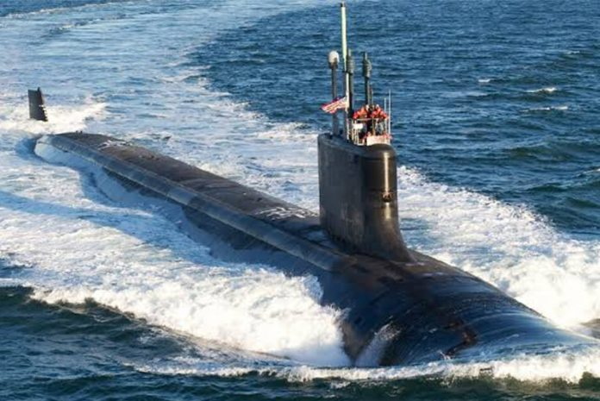
“Offence is the best form of defence” is an adage that has been applied to many forms of competitive endeavours, including sports and military combat. The idea is that one’s offensive posture could preoccupy the other side with defensive tasks and hinder their ability to attack. Being a long-time soccer fan, I have seen this assertion being borne out times aplenty in The Beautiful Game.
Take the example of top Spanish side FC Barcelona, a team that often deploys three attackers around the halfway line while defending a corner kick. Given that the norm is to have one, at most two, players upfield in this situation, it is perhaps an inordinately offensive approach during a defensive situation on Barcelona’s part. This means, however, that the opponent needs to have at least four players directly keeping tabs on these three Barca players, with another one or two patrolling beyond the Barca penalty box as insurance. With players of the quality of Lionel Messi and Luis Suarez – two of the world’s top 10 strikers today – among the Barca strikeforce, it would be virtual suicide if the other side did not cover them closely. The upshot of Barca’s offensive posture is that fewer players from the other team are available to exploit corner kicks and other deep attacks.
Let us transpose FC Barcelona’s modus operandi while defending corners (referred to hereafter as the ‘Barca model’) to the realm of the United States’ military competition with China in the western Pacific. Much has been made about how during a notional Sino-American crisis or conflict, the People’s Liberation Army (PLA) could hold at risk United States and friendly forces within its burgeoning anti-access/area-denial (A2/AD) edifice. The tables could, however, be turned on the Chinese with the application of the Barca model.
This cost-imposition strategy entails the US deploying platforms that could make the Chinese devote a disproportionate amount of resources on defence; concomitantly reducing the A2/AD threat to friendly forces. This state of affairs is rather similar to how Messi dilutes opposing defences by drawing away defenders, leaving space for his colleagues to exploit.
The idea behind the Barca model can explain the underpinnings of the ‘maritime pressure’ strategy promulgated recently by a paper entitled Tightening the Chain: Implementing a Strategy of Maritime Pressure in the Western Pacific by the Center for Strategic and Budgetary Assessments (CSBA), where the accent is on land-based missile systems to complicate the PLA’s calculus. After all, a single road-mobile missile launcher adopting ‘shoot-and-scoot’ tactics could tie up significant military resources of an opponent. That said, the CSBA strategy gives relatively scant mention to another platform ideally suited for putting into practice the Barca model – the submarine.
It is a basic premise of military strategy that one’s strengths should be pitted against the adversary’s weaknesses. Indeed, undersea warfare is one of the few remaining areas where the US still holds an asymmetric edge over the Chinese, especially in the acoustic realm in the short and medium terms. Moreover, Chinese anti-submarine warfare (ASW) capabilities are rather limited, despite some advances made in this area in recent years. Hence two American military thinkers, Mark Montgomery and Eric Sayers, are right on point when they argue that, “(a)ttack submarines remain the key to defeating China should deterrence fail… they should be the top investment priority ahead of all other shipbuilding programs.”
History provides various examples where the submarine was able to exert strategic and operational effects disproportionate to its number(s). During the 1971 Indo-Pakistani War, the sinking of the Indian frigate Khukri by the Pakistani submarine Hangor forced the Indian Navy to abort an attack on Karachi. In addition, think of how, during the Falklands War, Argentina scurried its surface fleet, including its sole aircraft carrier, back to port following the sinking of the battleship General Belgrano’s by a Royal Navy submarine. The Argentine navy subsequently played no part in the conflict. On the other side of the coin, the presence of the ARA San Luis in the area of operations forced the British to devote a dozen surface combatants to anti-submarine efforts, but the Argentine boat escaped unscathed even after carrying out a number of – albeit unsuccessful – attacks on Royal Navy ships. In more recent times, such was the furtiveness of the air-independent propulsion submarine that the Indian Navy spent three weeks hunting for the Pakistani Agosta-class boat Saad before it was discovered.
Going Forward
An application of the Barca model would see the US submarine force coming up with a Diversion 2.0 strategy where its nuclear-powered hunter-killer boats (SSNs) are forward deployed in the western Pacific littorals to threaten Chinese naval interests in periods of exigency. For the uninitiated, the Diversion 1.0 strategy that was devised during the Cold War’s apogee saw American SSNs forward deployed to threaten Soviet nuclear-powered ballistic-missile submarines (SSBNs) in their bastions. It was successful to some extent as Moscow had to divert its attention to counter the American SSN challenge. An exact replica of Diversion 1.0 would, however, be unpalatable in the current Asia-Pacific security order given that it would undermine strategic stability by encouraging a ‘use-it-or-lose-it’ nuclear-weapons mentality on the part of the Chinese.
A more feasible Diversion 2.0 strategy could see attack boats being forward deployed to threaten the conventional PLA Navy (PLAN). In times of crisis or war, American (and allied) subs could enforce a blockade of major Chinese naval bases that host capital ships, especially aircraft carriers. Given their ‘Queen of the Waves’ status, the Chinese would do well to allocate more resources toward protecting these assets – resources that could be otherwise be used to threaten American naval forces. As the best ASW weapon is another submarine, the PLAN’s diversion of its subs to counter their American counterparts could enervate the undersea threat it poses to the US Navy.
All that being said, the “Messi” of the US Silent Service that would draw the most attention in Beijing is invariably its most-capable platform: the Virginia-class attack boat. Indeed, upcoming Virginias equipped with the Virginia Payload Module (VPM) which increases their firepower by some 75 percent are akin to a ‘Messi on steroids.’ After all, such a platform can hold up to 40 of the ship-killing Maritime Tomahawks in its vertical-launch system, making it a primus inter pares amongst anti-surface warfare platforms. A number of VPM-armed Virginias roaming the waters within the First Island Chain during a China-U.S. trial of arms would undoubtedly give the denizens of Zhongnahai (Communist Party Headquarters) a headache of the first order. In this light, the advocacy by various defence analysts that the number of Virginias built yearly be increased to three from the current two makes sheer good sense.
Going forward, much has been made of how, at the operational level, the Chinese would be attacking and the Americans defending, should the two sides duel in the western Pacific. In such circumstances, perhaps, it is time for the US Navy to seriously consider ‘the Barca model’ in order to reduce the pressure on its surface forces, and what better capability to execute this than its potent attack boats. Indeed, retired U.S. submarine admiral W. J. Holland Jr. once said that a cost-imposing strategy stressing the primacy of submarines is one that seeks “not just victory in war but deterrence by making evident the costs to compete and the prospect of a likely defeat in the event of war.” A 21st-century version of the Cold-War diversion strategy is thus of profound utility also in peacetime, and US naval chieftains would do well to bear this in mind as they grapple with the challenges of today’s Great-Power competition.

