Congress wrestles with deterring China ― beyond nukes
By: Joe Gould 16 Jan 2020
https://www.defensenews.com/congress/2020/01/16/congress-wrestles-with-deterring-chinabeyond-nukes/?utm_source=Sailthru&utm_medium=email&utm_campaign=EBB%2001.17.20&utm_term=Editorial%20-%20Early%20Bird%20Brief
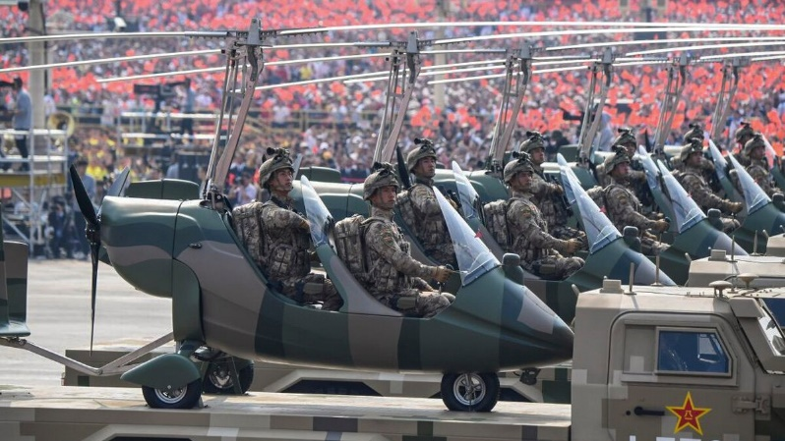
Military vehicles carrying military aircraft participate in a parade at Tiananmen Square in Beijing on Oct. 1, 2019, to mark the 70th anniversary of the founding of the People's Republic of China. (Greg Baker/AFP via Getty Images)
WASHINGTON ― Days after China’s navy commissioned its biggest and most advanced surface warship yet, on a path to an estimated 420 ships by 2035, key experts told Congress the U.S. must form a new and creative strategy to deter China, beyond nuclear weapons.
Addressing the House Armed Services Committee on Wednesday, former Under Secretary of Defense for Policy Michele Flournoy, former Joint Rapid Acquisition Cell Director Andrew Hunter and retired Rear Adm. Michael McDevitt warned that China is on track to outpace America technologically and at sea.
The three witnesses offered a number of concrete recommendations to preserve a credible security guarantee from America to its allies in the Pacific.
“The No. 1 military objective for the United States today should be to re-establish credible deterrence,” said Flournoy, who now leads WestExec Advisors. “Militarily, the resurgence of great power competition requires the United States to reimagine how we deter and, if necessary, fight and prevail in a future conflict with China. America’s military advantage is rapidly eroding in light of China’s modernization efforts.”
The remarks came a day after the U.S. Navy’s top officer told the annual Surface Navy Association symposium that his service needs a larger share of the military budget if it’s going to keep pace with China’s fast-growing Navy. But at the hearing, HASC Chairman Adam Smith indicated he wants solutions that would not fuel an arms race or unduly drain America’s coffers.
“I think it is a mistake to look at a problem and say: ‘We can’t constrain resources, we have to address the problem in any way we can,’ ” said Smith, D-Wash.
Numerical targets like the Navy’s 355-ship goal were outdated, Flournoy argued, suggesting a better goal would be the ability to hold the Chinese fleet at risk for 72 hours. That could involve the Navy’s long range anti-ship missiles on Air Force B-2 bombers in the near term. In the long term, that could include American land forces fielding distributed long-range artillery or hypersonic missiles across the Pacific but out of Chinese range.
"I’m not suggesting we sink the Chinese fleet in one day. What I am suggesting is that if we could say to them: ‘If you undertake this act of aggression, you are putting your entire fleet at risk immediately; do you understand?’ " Flournoy said. "That might be pretty good for deterrence.”
Then-U.S. Under Secretary of Defense for Policy Michele Flournoy arrives for a bilateral meeting with her Chinese counterpart on Dec. 7, 2011, in Beijing, China. (Andy Wong/Getty Images)
In a later exchange with Flournoy, Future of Defense Task Force co-chair Seth Moulton, D-Mass., questioned the deterrent effect of America’s large and costly nuclear arsenal. Flournoy acknowledged the strategic value of nuclear arms but said their cost can sap dollars from technological developments, adding that the emphasis should be on arms control agreements, conventional deterrence and new concepts.
“We have not gotten inside the Chinese leadership and their calculus with a depth of understanding to know how do we really effect their cost calculus in the near term with what we have, and in the long term with what we’re investing in. Most, if not all, of that is non-nuclear,” she said.
In October, China’s Communist Party marked 70 years in power with a military parade that showcased nuclear missiles designed to evade U.S. defenses and displayed a supersonic attack drone, among other products from two decades worth of weapons development. The display highlighted the country’s strategic goals of displacing the United States as the Asia-Pacific region’s dominant power and enforcing potentially volatile claims to Taiwan, the South China Sea and other disputed territories.
What about China’s new ship?
On Sunday, the Chinese People’s Liberation Army Navy commissioned its biggest and most advanced surface warship yet ― its first 10,000-ton-class Type 055 destroyer, according to The Japan Times. The ship is expected to accompany aircraft carriers in battle groups and is seen a step forward as Beijing seeks to operate farther from its shores and into the western Pacific.
Though China’s shipbuilding goal is secret, it likely aims to have 420 ships by 2035, according to McDevitt, now with the Center for Naval Analyses. Beijing is starting to field a capable expeditionary force that includes marines, large amphibious ships, carriers and logistics vessels, which could be fielded throughout the Pacific and along Africa’s littorals.
“China is certainly not preeminent in the eastern Pacific, the Indian Ocean, the Mediterranean Sea or the Atlantic Ocean ― but it is working on it,” McDevitt said, adding that China now has “the second-largest blue water navy in the world.”
Rather than trying to match China ship for ship, the U.S. ought to work to improve the troubled littoral combat ship instead of writing it off, he said. (The Navy’s littoral combat ship Gabrielle Giffords deployed in September with the service’s new Naval Strike Missile, transforming the LCS from an under-gunned concept gone awry to a legitimate threat to Chinese warships at significant ranges.)
Asked for potential areas of investment for the Department of Defense, McDevitt suggested Washington encourage allies in the region to develop, like Australia, an ability to counter China’s anti-access/area-denial forces, and to increase the number of U.S. nuclear attack submarines deployed to the region from as little as eight to as much as 15, with four of those based in Japan.
The Pentagon should also find a means to temporarily interrupt China’s ability to target U.S. ships, McDevitt said ― likely through jamming or some sort of anti-satellite warfare.
“China is becoming as dependent as we are on space, cyber networks, and so without their ability to surveil the open ocean, they can’t use their anti-ship ballistic missiles; they don’t know where to vector their diesel submarine; they don’t know where to launch their land-based aircraft,” McDevitt said.
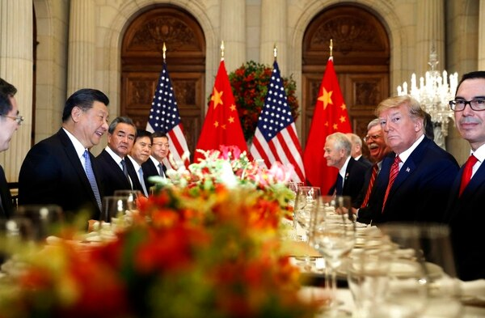
U.S. President Donald Trump, second from right, and Chinese President Xi Jinping, second from left, attend a bilateral meeting Dec. 1, 2018, at the G-20 summit in Buenos Aires, Argentina. (Pablo Martinez Monsivais/AP)
Likewise, China might hack American systems to prevent U.S. military assets from responding to a crisis. To counter that, Flournoy said, the U.S. military must mature its developing Advanced Battle Management System, which the Air Force hopes will weave information collected by various platforms into a total picture of the battlespace.
“It will require advancements in sensor integration, data processing, artificial intelligence, network integration to all the different shooters and actors, network integration, and cloud computing,” she said.
Flournoy also highlighted a strong potential role of unmanned systems for intelligence, surveillance and reconnaissance, strike, and counter-mine missions, as well as extra-large undersea drones.
That dovetailed with a wide-ranging conversation about China’s efforts to outpace the United States economically and technologically, and how the Pentagon can catch up. The experts offered ideas to help the Defense Department overcome its struggles to quickly adapt new technologies and develop software ― which will mean creating new flexible budgeting authorities, moving money from legacy programs to new technologies and finding new ways to attract tech talent.
One problem is that innovative commercial firms that net DoD development funding will often wait in a “valley of death” for the DoD’s production decision. Flournoy suggested a bridge fund for such firms―in competitive areas like artificial intelligence, cybersecurity and quantum computing―as a way to stave off pressure from their investors to walk away from the department rather than wait.
Though Congress has granted the Pentagon a range of flexible authorities for quick contracting, the acquisitions workforce has lagged in using them, said Hunter, the former Joint Rapid Acquisition Cell director.
Another problem area has been the red tape involved with shifting money between procurement, research and development, and operations and maintenance accounts; and yet another problem is that acquisition officials are too timid about launching new-start programs.
“I’m trying to think of a polite way to say it," Hunter said. “No one knows what is going on with new starts: There are 15 different definitions of what they are, and people tend to take the most conservative approach, which means that they are constantly holding and waiting for approval on things that should be moving out.”
The Associated Press contributed to this report.

